
Faculty of Science

Course: CSCI 2020u – Software System Development & Integration
Component: Assignment
Weight: 10%
Deadline: March 6, 2019 (due by 11:59pm)

Collaboration Policy
You are permitted to work on this assignment in a team, and submit the results as a team. For this sort of assignment, with an open-ended component, the collaboration between multiple team members can be beneficial. Between groups, however, please limit the discussion to the level of general strategy (not code). Groups of size 2 are recommended. Larger groups will be considered with the proviso that the marker will mark your assignment with higher expectations. In any case, be sure that all members of the team fully understand all code, otherwise they will miss intended learning objectives, which may be a considerable disadvantage at exam time.

How to Submit
You will maintain a git repository for this assignment, which is a public repository. To submit the assignment, create a single file ‘README.txt’ that contains instructions on how to download, compile, and run your codes for each question. A .zip, .7z, or .rar file will not be acceptable. Also submit this word file (once you complete) into related drop box on Blackboard before deadline.

Note: Comments are mandatory. Failure to properly document your program will result in a deduction on the marks you receive for this (and any other) assignment.

Remember:
You need to complete this file and submit it in related drop box on Blackboard, in addition to uploading your codes in your git repository, before deadline.

Question 1: Displaying Three Cards

Problem Description:
Display a frame that contains three labels. Each label displays a card, as shown in the figure below. The card image files are named 1.png, 2.png, ..., 54.png and stored in the image/card directory. All three cards are distinct and selected randomly.

The image icons can be found in the attached card folder.

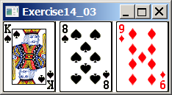

Your Task:
- Create three ImageView and set their icons using the images.
- Display three images from 54 image cards randomly.

Your Code:
Copy-paste your code here:

import javafx.application.Application;
import javafx.stage.Stage;
import javafx.scene.Scene;
import javafx.scene.image.Image;
import javafx.scene.image.ImageView;
import javafx.scene.layout.HBox;
import javafx.geometry.Insets;
import java.util.ArrayList;

public class part1 extends Application {
@Override // Override the start method in the Application class
public void start(Stage primaryStage) {
// Create a list of card numbers
ArrayList<Integer> cards = getCards();
// Create a HBox pane
HBox pane = new HBox(5);
pane.setPadding(new Insets(5, 5, 5, 5));

// Add nodes to pane
for (int i = 0; i < 3; i++) {
pane.getChildren().add(new ImageView(new Image("file:C:\\Users\\desai\\Desktop\\CSCI2020\\Assignments\\Cards\\" +
cards.get(i) + ".png")));
}

// Create a scene and place it in the stage
Scene scene = new Scene(pane);
primaryStage.setTitle("Displaying three random cards"); // Set the stage title
primaryStage.setScene(scene); // Place the scene in the stage
primaryStage.show(); // Display the stage
}

/** Returns a list with numbers 1-52 stored in random order */
private ArrayList<Integer> getCards() {
ArrayList<Integer> cards = new ArrayList<>();
for (int i = 0; i < 52; i++) {
cards.add(i + 1);
}
java.util.Collections.shuffle(cards);
return cards;
}
}

Screen shots:
Include two screen shots here:

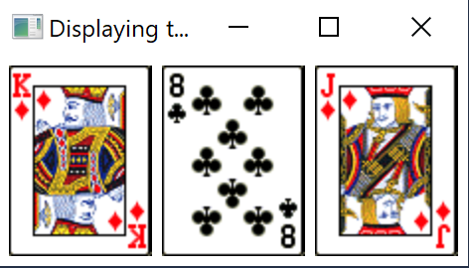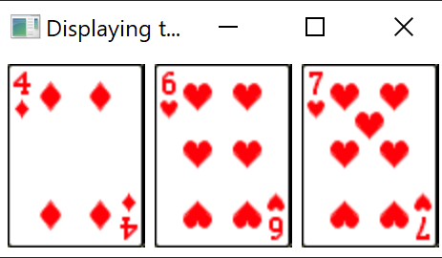

Question 2: Investment-Value calculator

Problem Description:
Write a program that calculates the future value of an investment at a given interest rate for a specified number of years. The formula for the calculation is as follows:

futureValue = investmentAmount * (1 + monthlyInterestRate)years*12

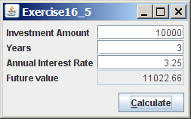

Your Task:
Use text fields for interest rate, investment amount, and years. Display the future amount in a text field when the user clicks the Calculate button, as shown in the figure.

Your Code:
Copy-paste your code here:

import javafx.application.Application;
import javafx.geometry.Insets;
import javafx.geometry.Pos;
import javafx.scene.Scene;
import javafx.scene.control.Button;
import javafx.scene.control.Label;
import javafx.scene.control.TextField;
import javafx.scene.layout.GridPane;
import javafx.scene.layout.HBox;
import javafx.stage.Stage;

public class part2 extends Application {

@Override
public void start(Stage primaryStage) throws Exception {

LoanInvestCalcPane calcPane = new LoanInvestCalcPane();

primaryStage.setScene(new Scene(calcPane, calcPane.getPrefWidth(), calcPane.getPrefHeight()));
primaryStage.setTitle("Simple calculator");
primaryStage.show();
}

public static void main(String[] args) {

Application.launch(args);
}

private class LoanInvestCalcPane extends GridPane {

Label lbInvestAmount = new Label("Invest Amount:");
TextField tfInvestAmount = new TextField();

Label lbNumberOfYears = new Label("Number Of Years:");
TextField tfNumberOfYears = new TextField();

Label lbAnnualInterestRate = new Label("Annual Interest Rate:");
TextField tfAnnualInterestRate = new TextField();

Label lbFutureValue = new Label("Future Value:");
TextField tfFutureValue = new TextField();

Button btCalc = new Button("Calculate");

private LoanInvestCalcPane() {

// Create layout
setPadding(new Insets(10, 10, 10, 10));
setAlignment(Pos.CENTER);
setHgap(10);
setVgap(10);

add(lbInvestAmount, 0, 0);
add(tfInvestAmount, 1, 0);

add(lbNumberOfYears, 0, 1);
add(tfNumberOfYears, 1, 1);

add(lbAnnualInterestRate, 0, 2);
add(tfAnnualInterestRate, 1, 2);

add(lbFutureValue, 0, 3);
add(tfFutureValue, 1, 3);

HBox buttons = new HBox();
buttons.getChildren().add(btCalc);
buttons.setAlignment(Pos.BOTTOM_RIGHT);
add(buttons, 1, 4);
btCalc.setOnAction(e-> calcFutureValue());

// Editing TextField settings
TextField[] textFields = (TextField[])getArray(
tfInvestAmount, tfNumberOfYears, tfAnnualInterestRate, tfFutureValue);

for (TextField tf : textFields) {
tf.setAlignment(Pos.BASELINE_RIGHT);
}
tfFutureValue.setDisable(true);

}

private Object[] getArray(Object... objects) {
Object[] temp = new TextField[objects.length];
for (int i = 0; i < objects.length; i++) {
temp[i] = objects[i];
}
return temp;
}

public void calcFutureValue() {
double investmentAmount = Double.parseDouble(tfInvestAmount.getText());
double years = Double.parseDouble(tfNumberOfYears.getText());
double monthInterestRate = Double.parseDouble(tfAnnualInterestRate.getText()) / 12 / 100;

double futureValue = investmentAmount * Math.pow(1 + monthInterestRate, years * 12);
tfFutureValue.setText(String.format("$%.2f", futureValue));
}
}
}

Screen shots:
Include two screen shots here:

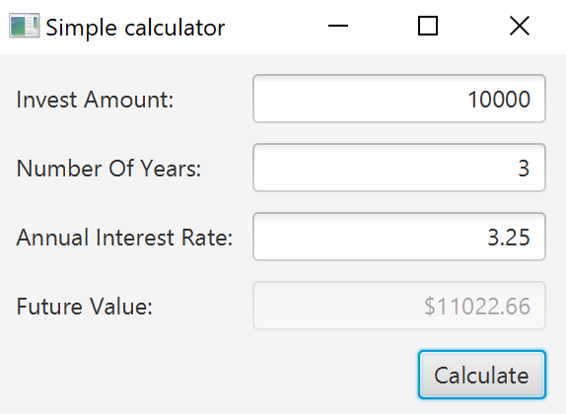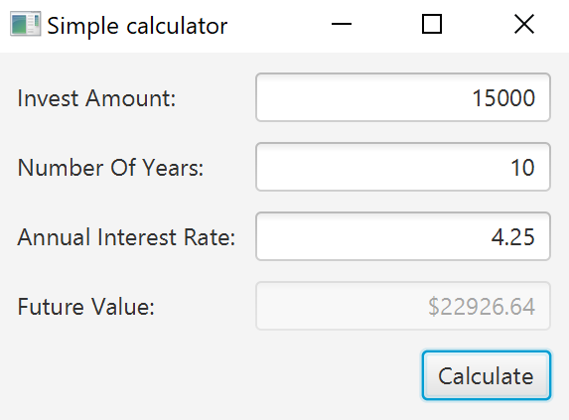
Question 3: Dragging Points on a Circle

Problem Description:
Draw a circle with three random points on the circle. Connect the points to form a triangle. Display the angles in the triangle. Use the mouse to drag a point along the perimeter of the circle. As you drag it, the triangle and angles are redisplayed dynamically.

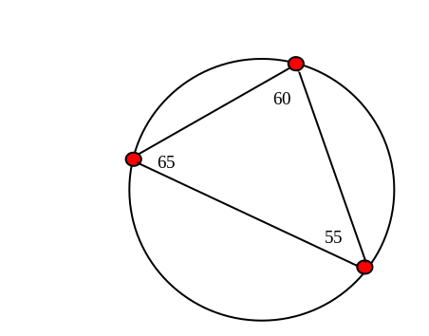

Here is the formula to compute angles:

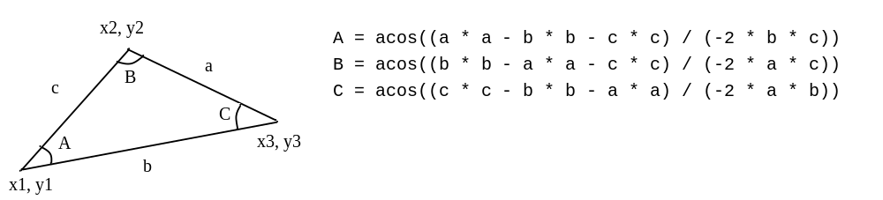

Your Code:
Copy-paste your code here:

import javafx.application.Application;
import javafx.stage.Stage;
import javafx.scene.Scene;
import javafx.scene.layout.Pane;
import javafx.scene.shape.Circle;
import javafx.scene.shape.Line;
import javafx.scene.text.Text;
import javafx.scene.paint.Color;
import javafx.scene.input.MouseButton;

public class part3 extends Application {
@Override
public void start(Stage primaryStage) {
final double WIDTH = 500.0;
final double HEIGHT = 500.0;
final double RADIUS = 200.0;

Circle[] points = new Circle[3];
Line[] lines = new Line[3];
Text[] labels = new Text[3];
Pane pane = new Pane();
Circle circle = new Circle(WIDTH / 2, HEIGHT / 2, RADIUS);
circle.setFill(Color.WHITE);
circle.setStroke(Color.BLACK);
pane.getChildren().add(circle);

// create three points around the circle represented by Circle objects
for (int i = 0; i < 3; i++) {
Circle point = new Circle(RADIUS / 20);
double randomAngle = Math.random() * 2 * Math.PI;
double x = circle.getCenterX() + RADIUS * Math.cos(randomAngle);
double y = circle.getCenterY() + RADIUS * Math.sin(randomAngle);
point.setCenterX(x);
point.setCenterY(y);
point.setOnMouseDragged(e -> {
if (e.getButton().equals(MouseButton.PRIMARY)) {
double angle = Math.atan2(e.getY() - circle.getCenterY(), e.getX() - circle.getCenterX());
Circle c = (Circle)e.getSource();
c.setCenterX(circle.getCenterX() + RADIUS * Math.cos(angle));
c.setCenterY(circle.getCenterY() + RADIUS * Math.sin(angle));
angle = getAngle(lines[1], lines[2], lines[0]);
labels[0].setText(String.format("%.5f", angle));
angle = getAngle(lines[2], lines[1], lines[0]);
labels[1].setText(String.format("%.5f", angle));
angle = getAngle(lines[0], lines[2], lines[1]);
labels[2].setText(String.format("%.5f", angle));
}
});
points[i] = point;
}

// create three lines connecting the points
for (int i = 0; i < 3; i++) {
int next = i == 2 ? 0 : i + 1;
Line line = new Line();
line.startXProperty().bind(points[i].centerXProperty());
line.startYProperty().bind(points[i].centerYProperty());
line.endXProperty().bind(points[next].centerXProperty());
line.endYProperty().bind(points[next].centerYProperty());
lines[i] = line;
}

// create three Text objects to display the angles
for (int i = 0; i < 3; i++) {
Text text = new Text();
text.xProperty().bind(points[i].centerXProperty());
text.yProperty().bind(points[i].centerYProperty().subtract(RADIUS / 20));
labels[i] = text;
}

pane.getChildren().addAll(points[0], points[1], points[2],
lines[0], lines[1], lines[2], labels[0], labels[1], labels[2]);

Scene scene = new Scene(pane, WIDTH, HEIGHT);
primaryStage.setTitle("CircleWithPointsandDegrees");
primaryStage.setScene(scene);
primaryStage.show();
}

public static double getAngle(Line x, Line y, Line z) {
double a = distance(x);
double b = distance(y);
double c = distance(z);
return Math.toDegrees(Math.acos((a * a - b * b - c * c) / (-2 * b * c)));
}

public static double distance(Line line) {
double x1 = line.getStartX();
double y1 = line.getStartY();
double x2 = line.getEndX();
double y2 = line.getEndY();
return Math.sqrt(Math.pow(x1 - x2, 2) + Math.pow(y1 - y2, 2));
}

public static void main(String[] args) {
launch(args);
}
}

Screen shots:
Include two screen shots here:

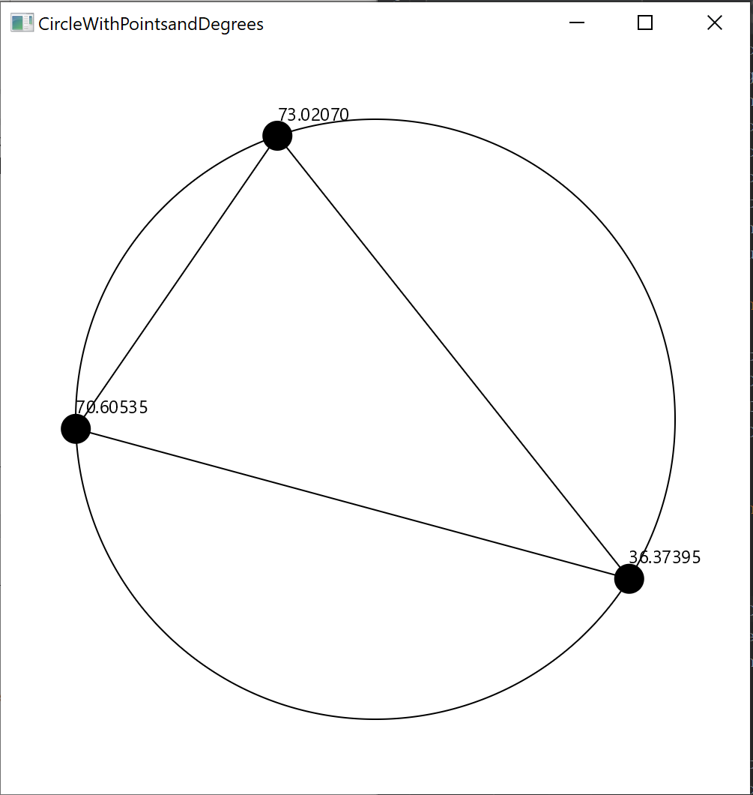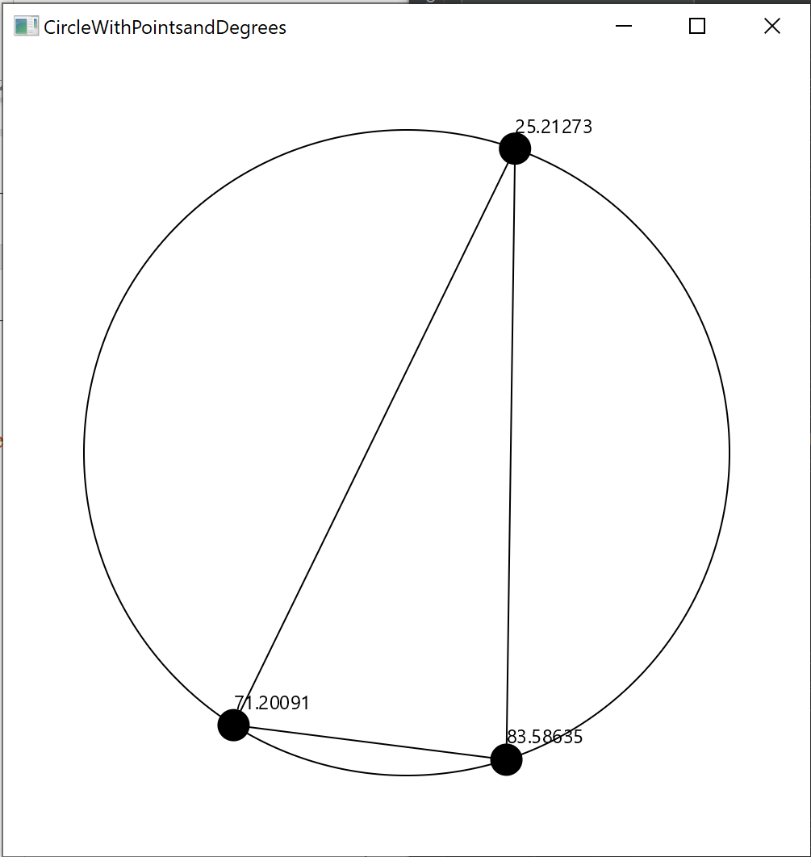

Question 4: Histogram

Problem Description:
Develop a program that displays a histogram to show the occurrences of each letter in a text area. The histogram should show the occurrences of each letter in a text file, as shown in the following figure. Assume that the letters are not case sensitive.

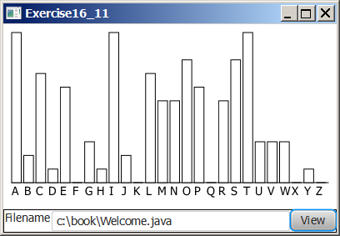

Your Task:
- Place a pane that will display the histogram in the center of the frame.
- Place a label and a text field in a panel, and put the panel in the south side of the frame. The text file will be entered from this text field.
- Pressing the Enter key on the text field causes the program to count the occurrences of each letter and display the count in a histogram.

Your Code:
Copy-paste your code here:

FileOpener.java:

import javafx.application.Application;
import javafx.scene.Scene;
import javafx.scene.control.Button;
import javafx.scene.control.ContentDisplay;
import javafx.scene.control.Label;
import javafx.scene.control.TextField;
import javafx.scene.layout.HBox;
import javafx.scene.layout.Pane;
import javafx.scene.layout.VBox;
import javafx.stage.Stage;

public class FileOpener extends Application {

Pane pane = new Pane();
TextField textField = new TextField();
VBox box = new VBox();
@Override
public void start(Stage primaryStage) throws Exception {

primaryStage.setTitle("Histogram");
Label lblFilename = new Label("Filename:", textField);
lblFilename.setContentDisplay(ContentDisplay.RIGHT);
textField.setPrefColumnCount(20);
Button btView = new Button("View");

HBox hBox = new HBox(lblFilename, btView);

box.getChildren().addAll(pane, hBox);
Scene scene = new Scene(box);
primaryStage.setScene(scene);
btView.setOnAction(e-> {
update();
box.setTranslateY(10);
primaryStage.sizeToScene();

});
primaryStage.show();
}

private void update() {
Histogram graph = new Histogram(textField.getText());
pane.getChildren().add(graph);
}

public static void main(String[] args) {
Application.launch(args);
}
}

Histogram.java:

import javafx.geometry.VPos;
import javafx.scene.control.ContentDisplay;
import javafx.scene.control.Label;
import javafx.scene.layout.GridPane;
import javafx.scene.layout.Pane;
import javafx.scene.shape.Rectangle;

import java.io.File;
import java.io.IOException;
import java.util.Scanner;

public class Histogram extends Pane {

private char[] chars = new char[26];
private int counts[] = new int[26];
private Rectangle[] bars = new Rectangle[26];
private File file;
GridPane pane;

double w = 350;
double h = 350;

public Histogram(String filename) {

this.file = new File(filename.trim());

setWidth(w);
setHeight(h);
readFile();
draw();
}

private void readFile() {

Scanner scanner;
String s = "";
try {
scanner = new Scanner(file);
while (scanner.hasNextLine()) {

s += scanner.nextLine();
}
} catch (IOException ex) {
}

s = s.toUpperCase();
for (int i = 0; i < s.length(); i++) {
char character = s.charAt(i);
if (Character.isLetter(character)) {
counts[character - 'A']++;
}
}

}
private double getTotal() {
double total = 0;
for (int count : counts) {
total += count;
}
return total;
}

private void draw() {

pane = new GridPane();
double barW = w / chars.length;
double total = getTotal();

for (int i = 0; i < counts.length; i++) {
chars[i] = (char) ('A' + i);

double percentage = counts[i] / total;
double barH = h * percentage;

bars[i] = new Rectangle(barW, barH);
Label label = new Label(chars[i] + "", bars[i]);
label.setContentDisplay(ContentDisplay.TOP);

pane.add(label, i, 0);
GridPane.setValignment(label, VPos.BASELINE);

}
getChildren().addAll(pane);

}

public int[] getCounts() {
return counts;
}

public void setCounts(int[] counts) {
this.counts = counts;
draw();
}

}

Screen shots:
Include two screen shots here:

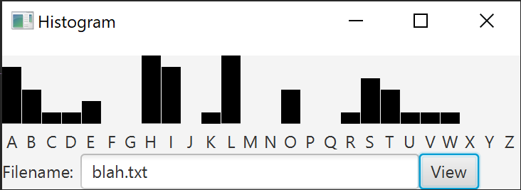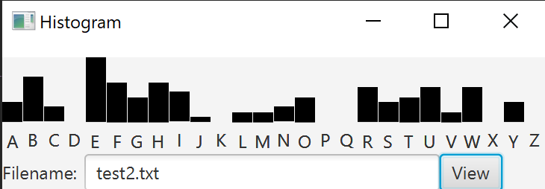

Remember:

You need to complete this file and submit it in related drop box on Blackboard, in addition to uploading your codes in your git repository, before deadline.

